# Walkthrough by location

[WEBAPP LINK](https://b-ricey763.github.io/lmc-3262-final-project/)

First three unlocked notes are just exposition, to be used to orient the player and give them the first clue

**Location 1**: House of the Weekend Club

**For note:** NOAH CLICK ME

**Sequence**:

* Go to club
* Open note
* Open conversation screenshots
* Walk to Saturn

**Location 2**: Outside Saturn electronics store

**For note:** first CLuez

**Answer / password for next note:** 5 (number of spherical stainless steel trash cans around the saturn store)

**Sequence of Events**:

* Open note (no password)
* Solve puzzle
* Use password on next note
* Go to Alexa mall

**Location 3**: **Inside Alexa Mall**

**For note:** puzzling words?

**Answer / password for next note:** 1495 (the cost of the scrabble game in the store)

**Sequence of Events**

* Open Note and find directions to bookstore called Thalia de Bucher, which is straight ahead from the entrance (you can use google maps)
* Inside bookstore find the scrabble (see img above). It’s near the right side of the sign
* Solve puzzle
* Go to world clock

**Location 4**: World Clock

**For note**: Clocking it ooout

**Answer / password for next note:** 10 (the hours between the two cities on the clock)

**Sequence of Events**:

* Open note
* Solve riddle
* Use password on next note
* Go to town hall/drill

**Location 5**: town hall / drill

* 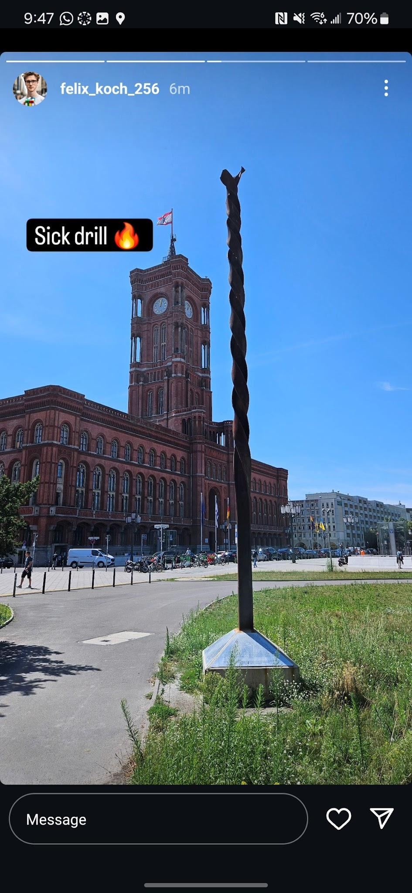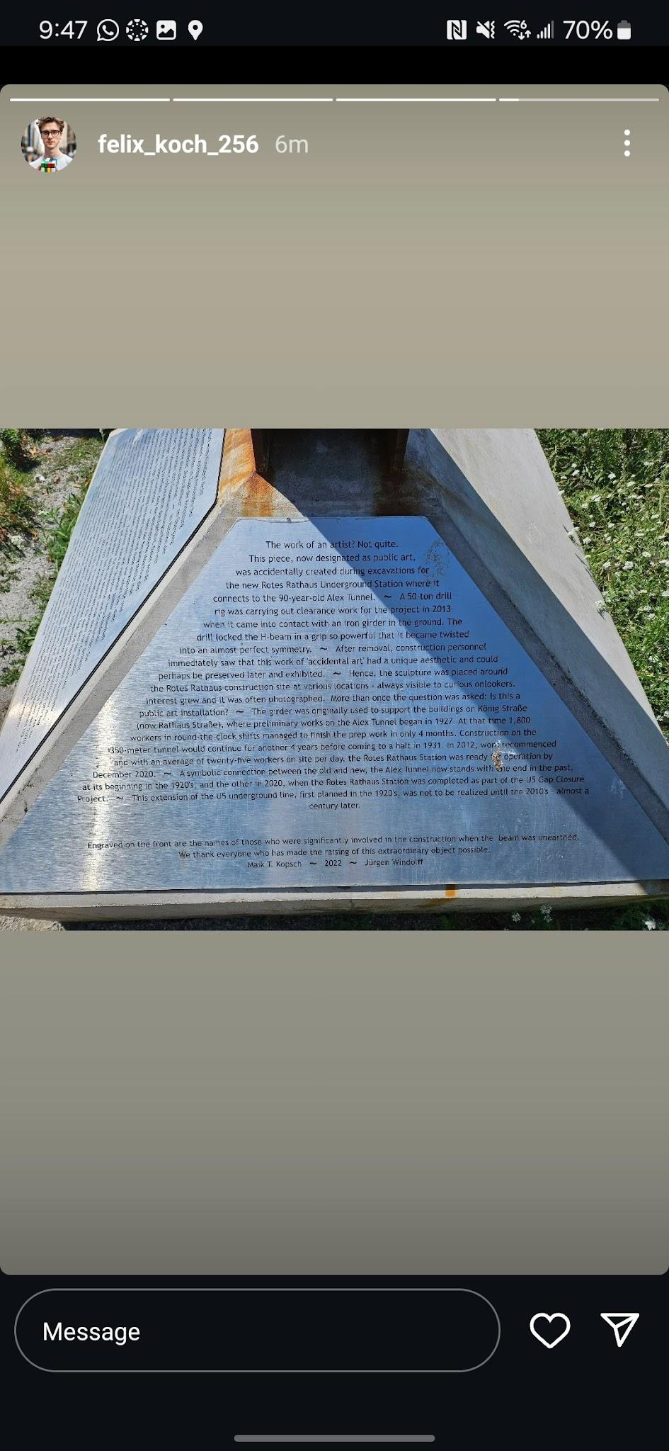

**For note:** big DRILLA

**Answer / Password for next note:** 1931 (when construction came to a halt after 4 years of work)

**Sequence of Events**:

* Open note, it doesn’t make sense at first.
* Use img with drill and town hall in the background to find the drill (relative to the town hall)
* Solve puzzle using cues from note and drill text
* Use password on next note

**Location 5**: TV Tower / Restaurant

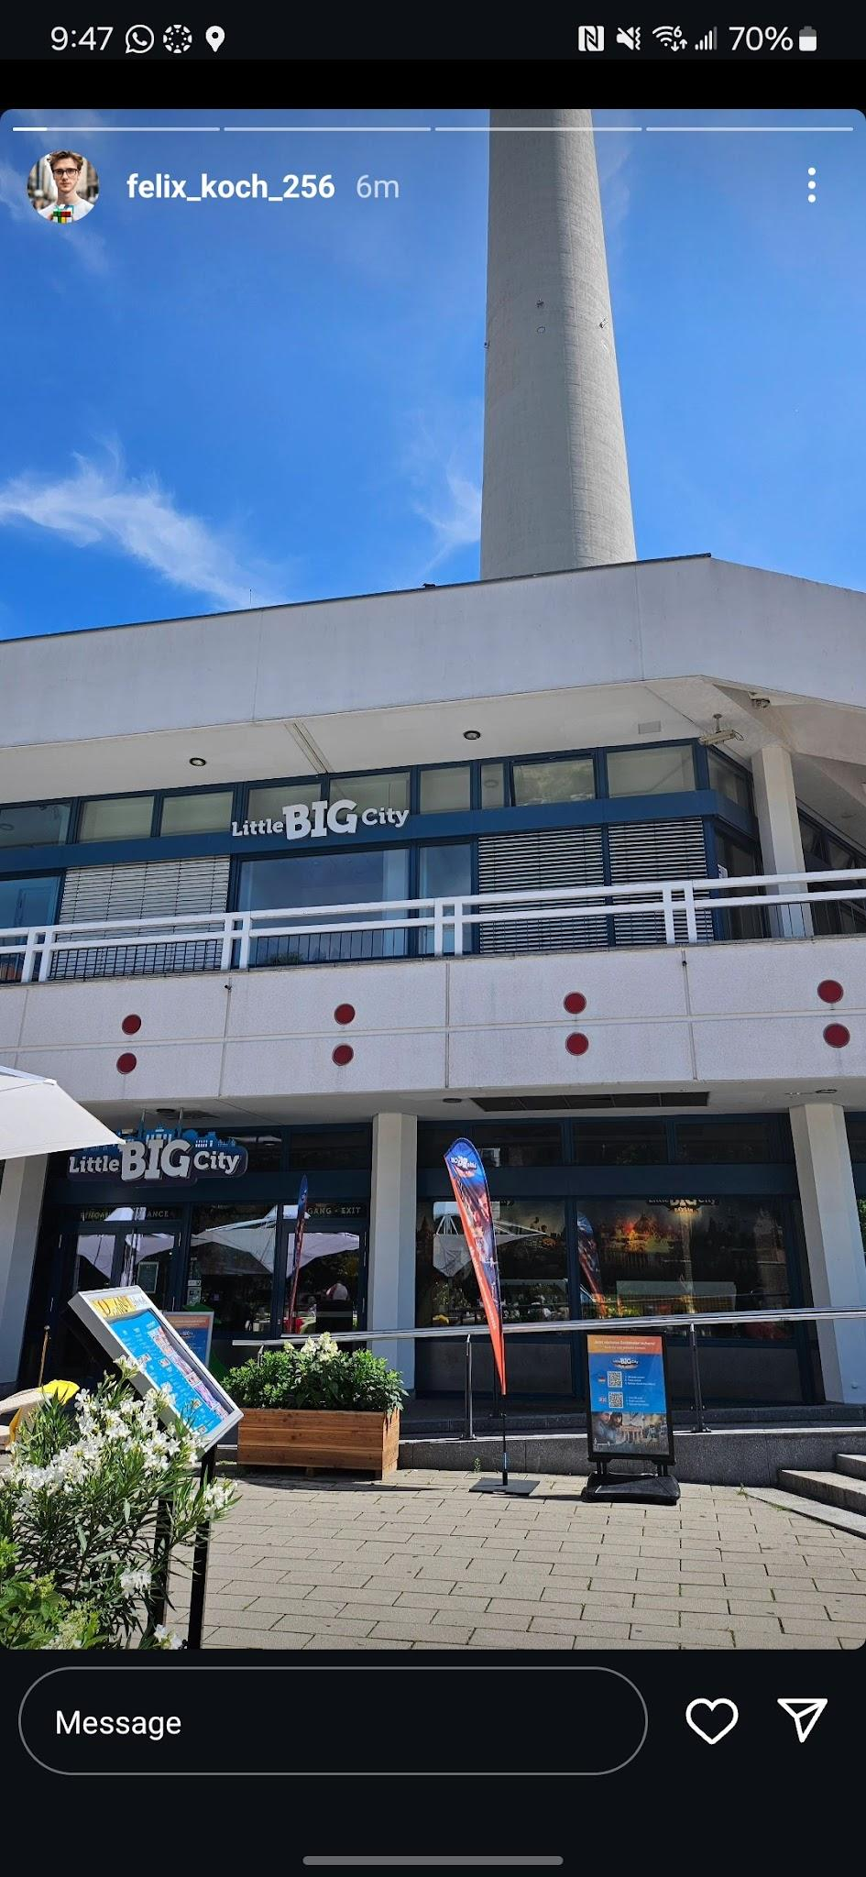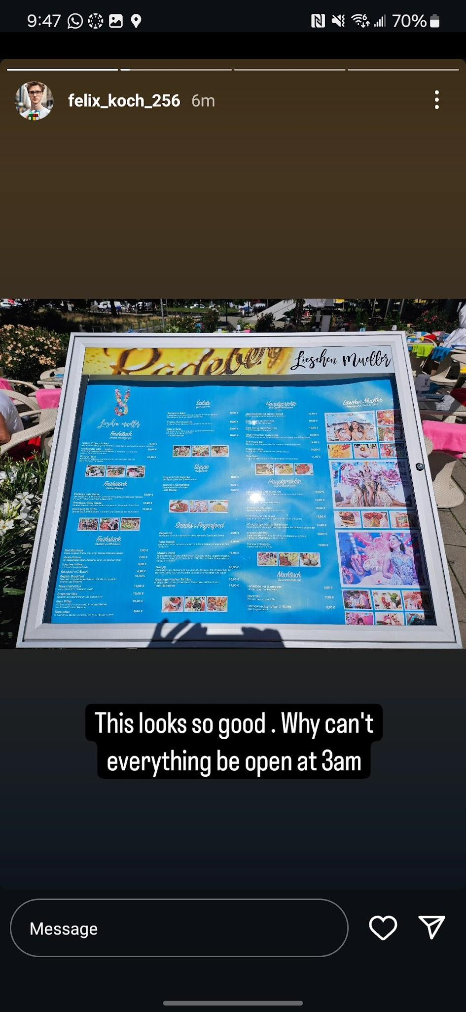

**For note:** idle 3/15

**Answer:** 1390 (the price of the Caesar salad in the salads portion of the menu. This refers to Julius Caesar, the roman dictator who was stabbed to death by his fellow statesmen)

**Sequence of Events**:

* Open note. Again, the note itself doesn’t make sense
* Use img if instagram story to find the restaurant Little Big City by name
* Find the Menu outside of the restaurant and use it along with the note to solve the puzzle
* Unlock next note using your password

**Location 5**: N/A, final puzzle

**For note:** the FINAL countdown

**Answer / password for next note:** take all of the lowercase letters in the line of each note talking about the battery percentage (for example: “BATTERY AT 26% hAVING FUN” would be “h”) it spells “church”

**Sequence of Events:**

* Go through previous notes and collect all lowercase letters
* They spell out church and that is the last password
* You unlock the final note and reflect.